
Rajvardhan Zende
202501100016
SE1 S11 ESSENTIALS OF DATA SCIENCE


PRACTICE LAB ASSIGNMENT
3.1.1 NUMPY ARRAY OPERATIONS
Writea Python programtocreate aNumPy array basedonuserinput and display the following: The created NumPyarray.
The number ofdimensionsof the array using ndim
The shape of the array using shape
The total number of elements in the array using size
Assume all input elements are valid integers.
Input Format:
The first line contains two space-separated integers, and , representing the number of rows and the number of columns.
The next lines contain space-separated integers representing the elements of the array, entered row by row.
Output Format:
The created NumPy array (printed as a 2D array).
An integer representing the number of dimensions of the array.
A tuple representing the shape of the array.
An integer representing the total number of elements in the array.

INPUT OUTPUT

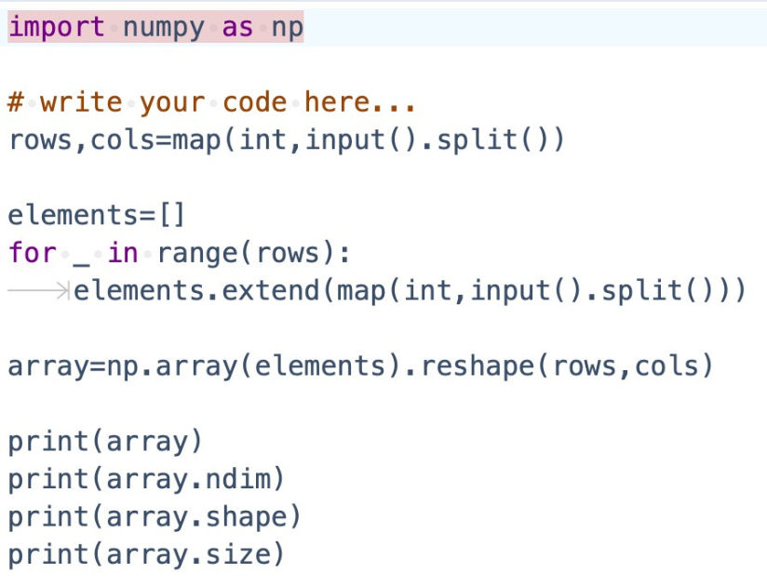

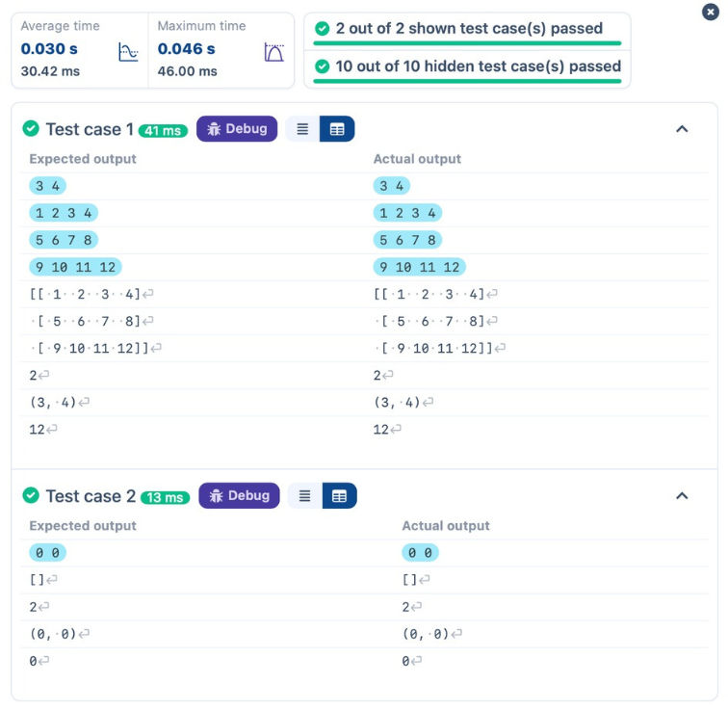


LAB ASSIGNMENT
3.2.1 NUMPY MATRIX OPERATIONS NumPyarrays.
Task:
You are required to compute and display the results of the following matrix operations:
1.Addition (matrix_a + matrix_b)
2.Subtraction (matrix_a - matrix_b)
3.Element-wise Multiplication (matrix_a * matrix_b)
4.Matrix Multiplication (matrix_a . matrix_b)
5.Transpose of Matrix A
Input Format:
The user will input 3 rows for matrix_a , each containing 3 integers separated by spaces.
Similarly, the user will input 3 rows for matrix_b, each containing 3 integers separated by spaces.
Output Format:
The program should display the results of the operations in the following order:
1.The result of Addition.
2.The result of Subtraction.
3.The result of Element-wise Multiplication.
4.The result of Matrix Multiplication.
5.The Transpose of Matrix A.

INPUT
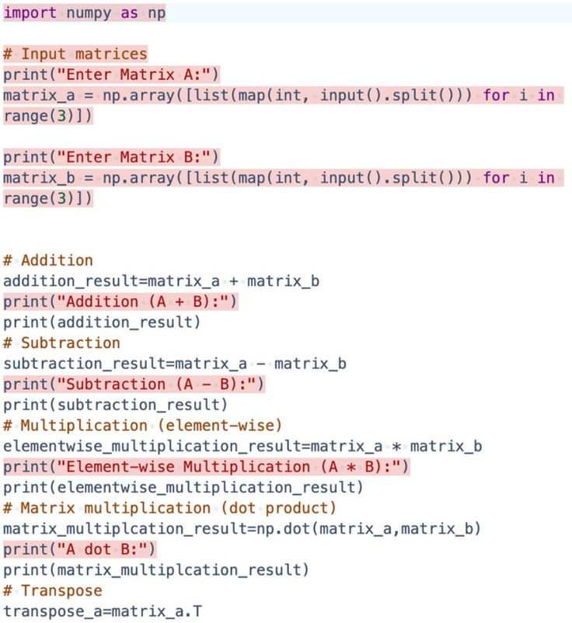

OUTPUT
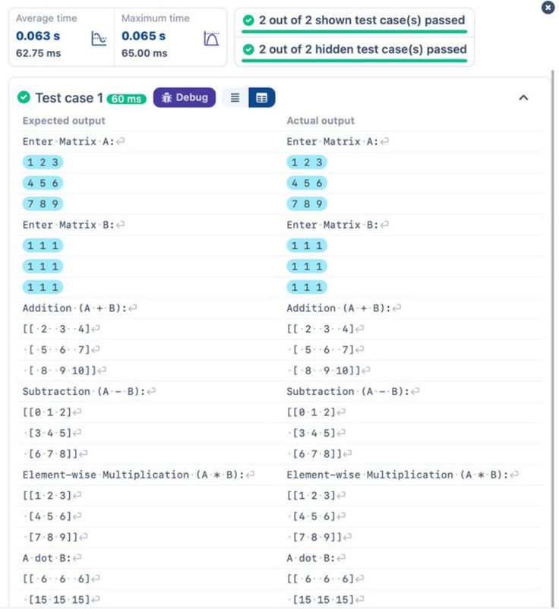
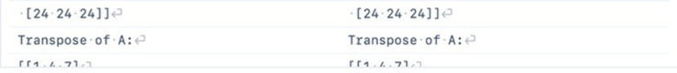

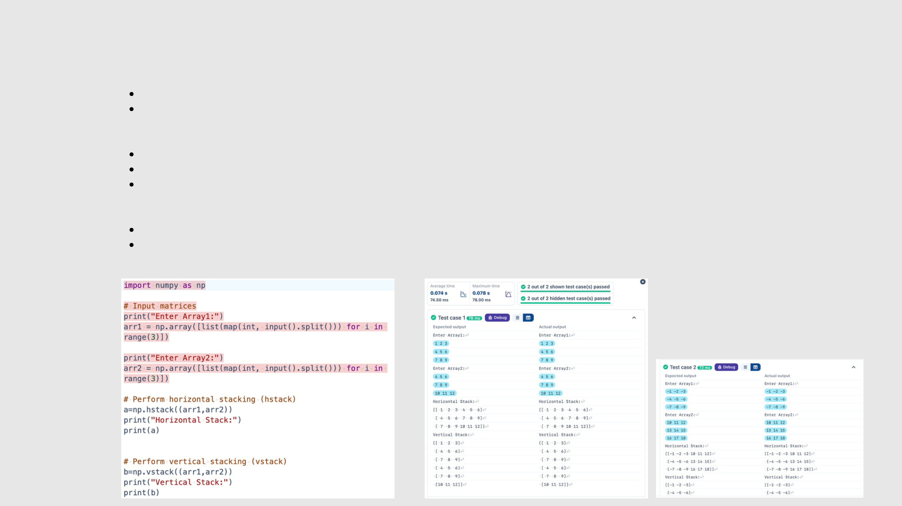
3.2.2 NUMPY HORIZONTAL AND VERTICAL STACKING OF ARRAYS
Youaregiventwoarrays arr1and arr2. Youneed toperformhorizontalandverticalstackingoperationsonthem using NumPy.
HorizontalStacking: Stack thetwo matrices horizontally (side byside).
Vertical Stacking: Stack the two matrices vertically (one below the other).
Input Format:
The program should first prompt the user to input two 3x3 arrays.
Each array consists of 3 rows, and each row contains 3 space-separated integers. The user will input the two arrays row by row.
Output Format:
The program should display the result of the Horizontal Stack (side-by-side stacking) of the two arrays. The program should then display the result of the Vertical Stack (one below the other) of the two arrays.
INPUT OUTPUT

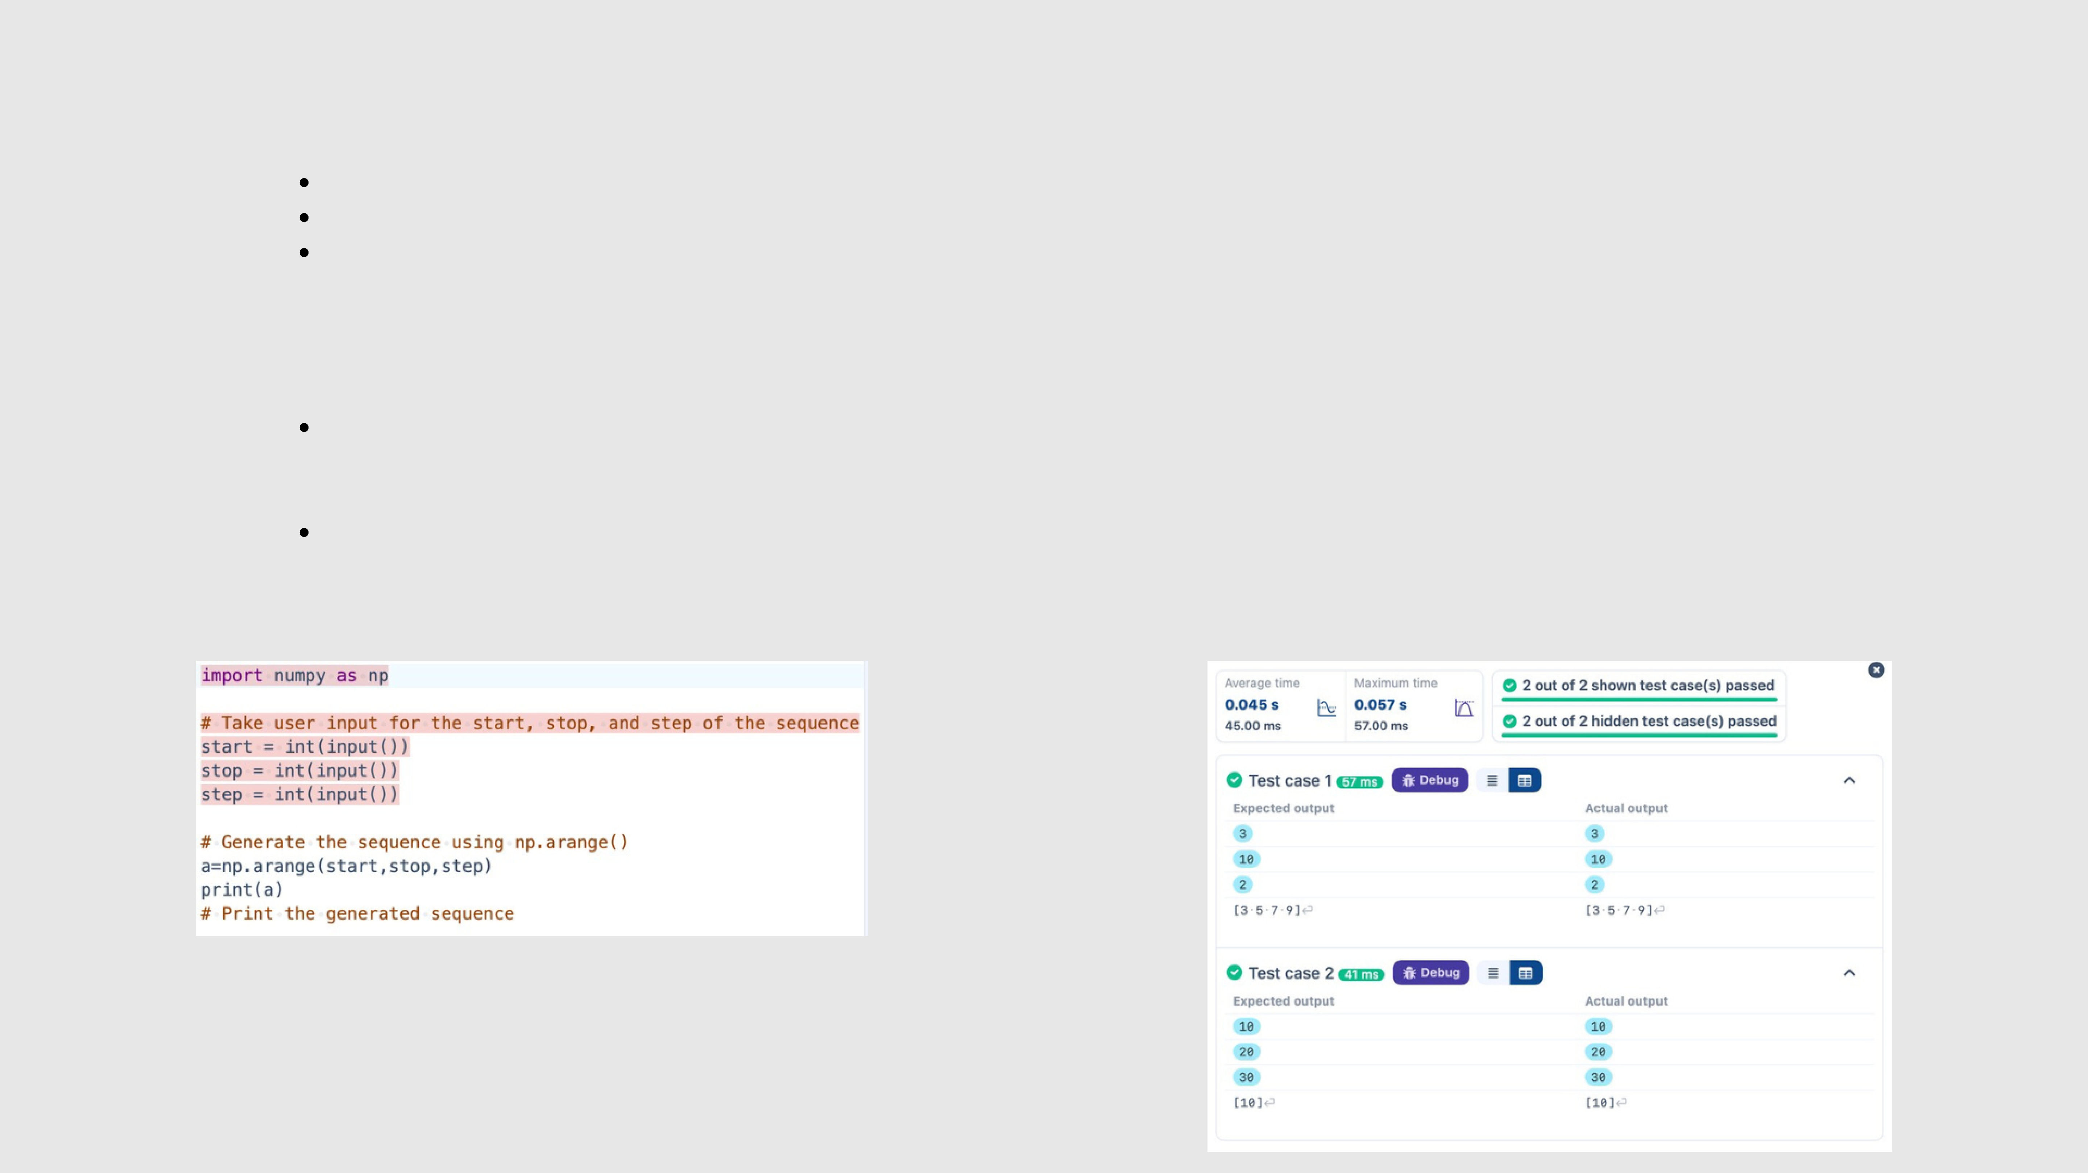
3.2.3 NUMPY:CUSTOM SEQUENCE GENERATION
WriteaPython programthattakesthefollowinginputsfromtheuser:
Start value: The startingpointof the sequence.
Stop value: The sequence should end beforethis value.
Step value: The increment between each number in the sequence.
The program should then generate a sequence using numpy based on these inputs and print the generated sequence.
Input Format:
The user will input three integer values: start, stop, and step, each on a new line.
Output Format:
The program should print the generated sequence based on the input values.
INPUT OUTPUT


3.2.4 NUMPY: ARITHMETIC AND STATISTICAL OPERATIONS,
MATHEMATICAL OPERATIONS, BITWISE OPERATORS
You are giventwo arrays AandB.Yourtaskistocompletethefunctionarray_operations,whichwillconvertthese lists into NumPy arrays andperformthefollowingoperations:
1. Arithmetic Operations:
Compute the element-wise sum, difference, and product of the two arrays.
2. Statistical Operations:
Calculate the mean, median, and standard deviation of array A.
3. Bitwise Operations:
Perform bitwise AND, bitwise OR, and bitwise XOR on the arrays (ex: A OR B ).
Input Format:
The first line contains space-separated integers representing the elements of array A. The second line contains space-separated integers representing the elements of array B.
Output Format:
For each operation (arithmetic, statistical, and bitwise), print the results in the specified format as shown in sample test cases.

INPUT
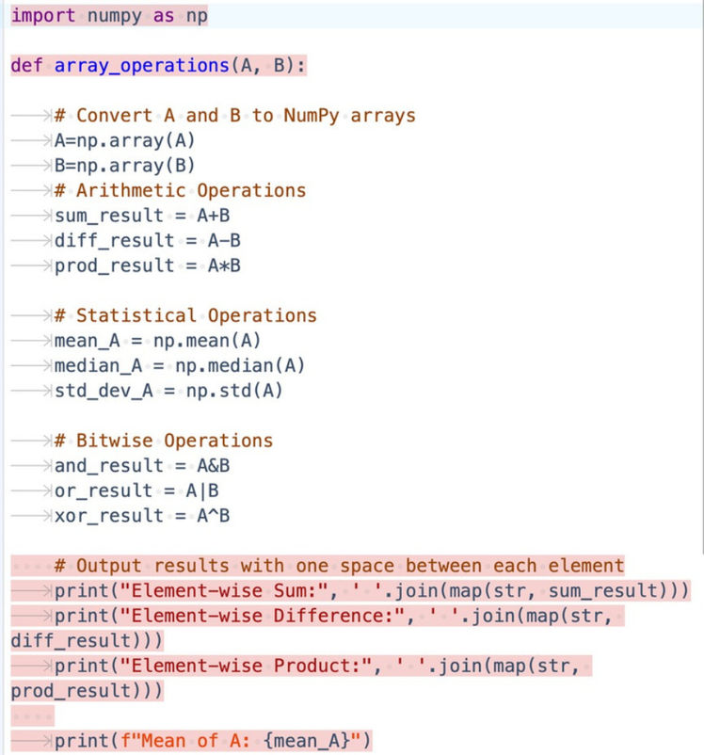
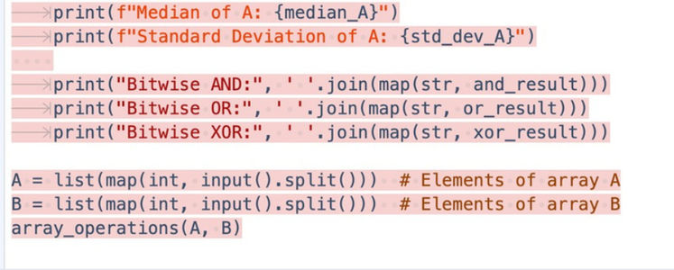

OUTPUT
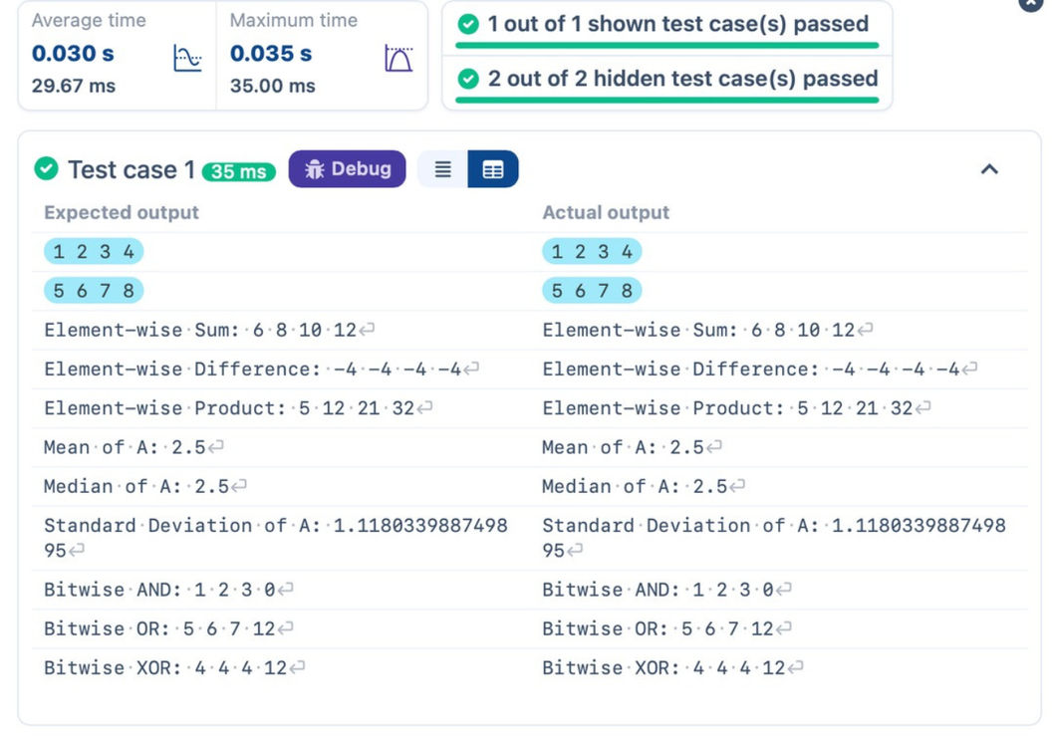

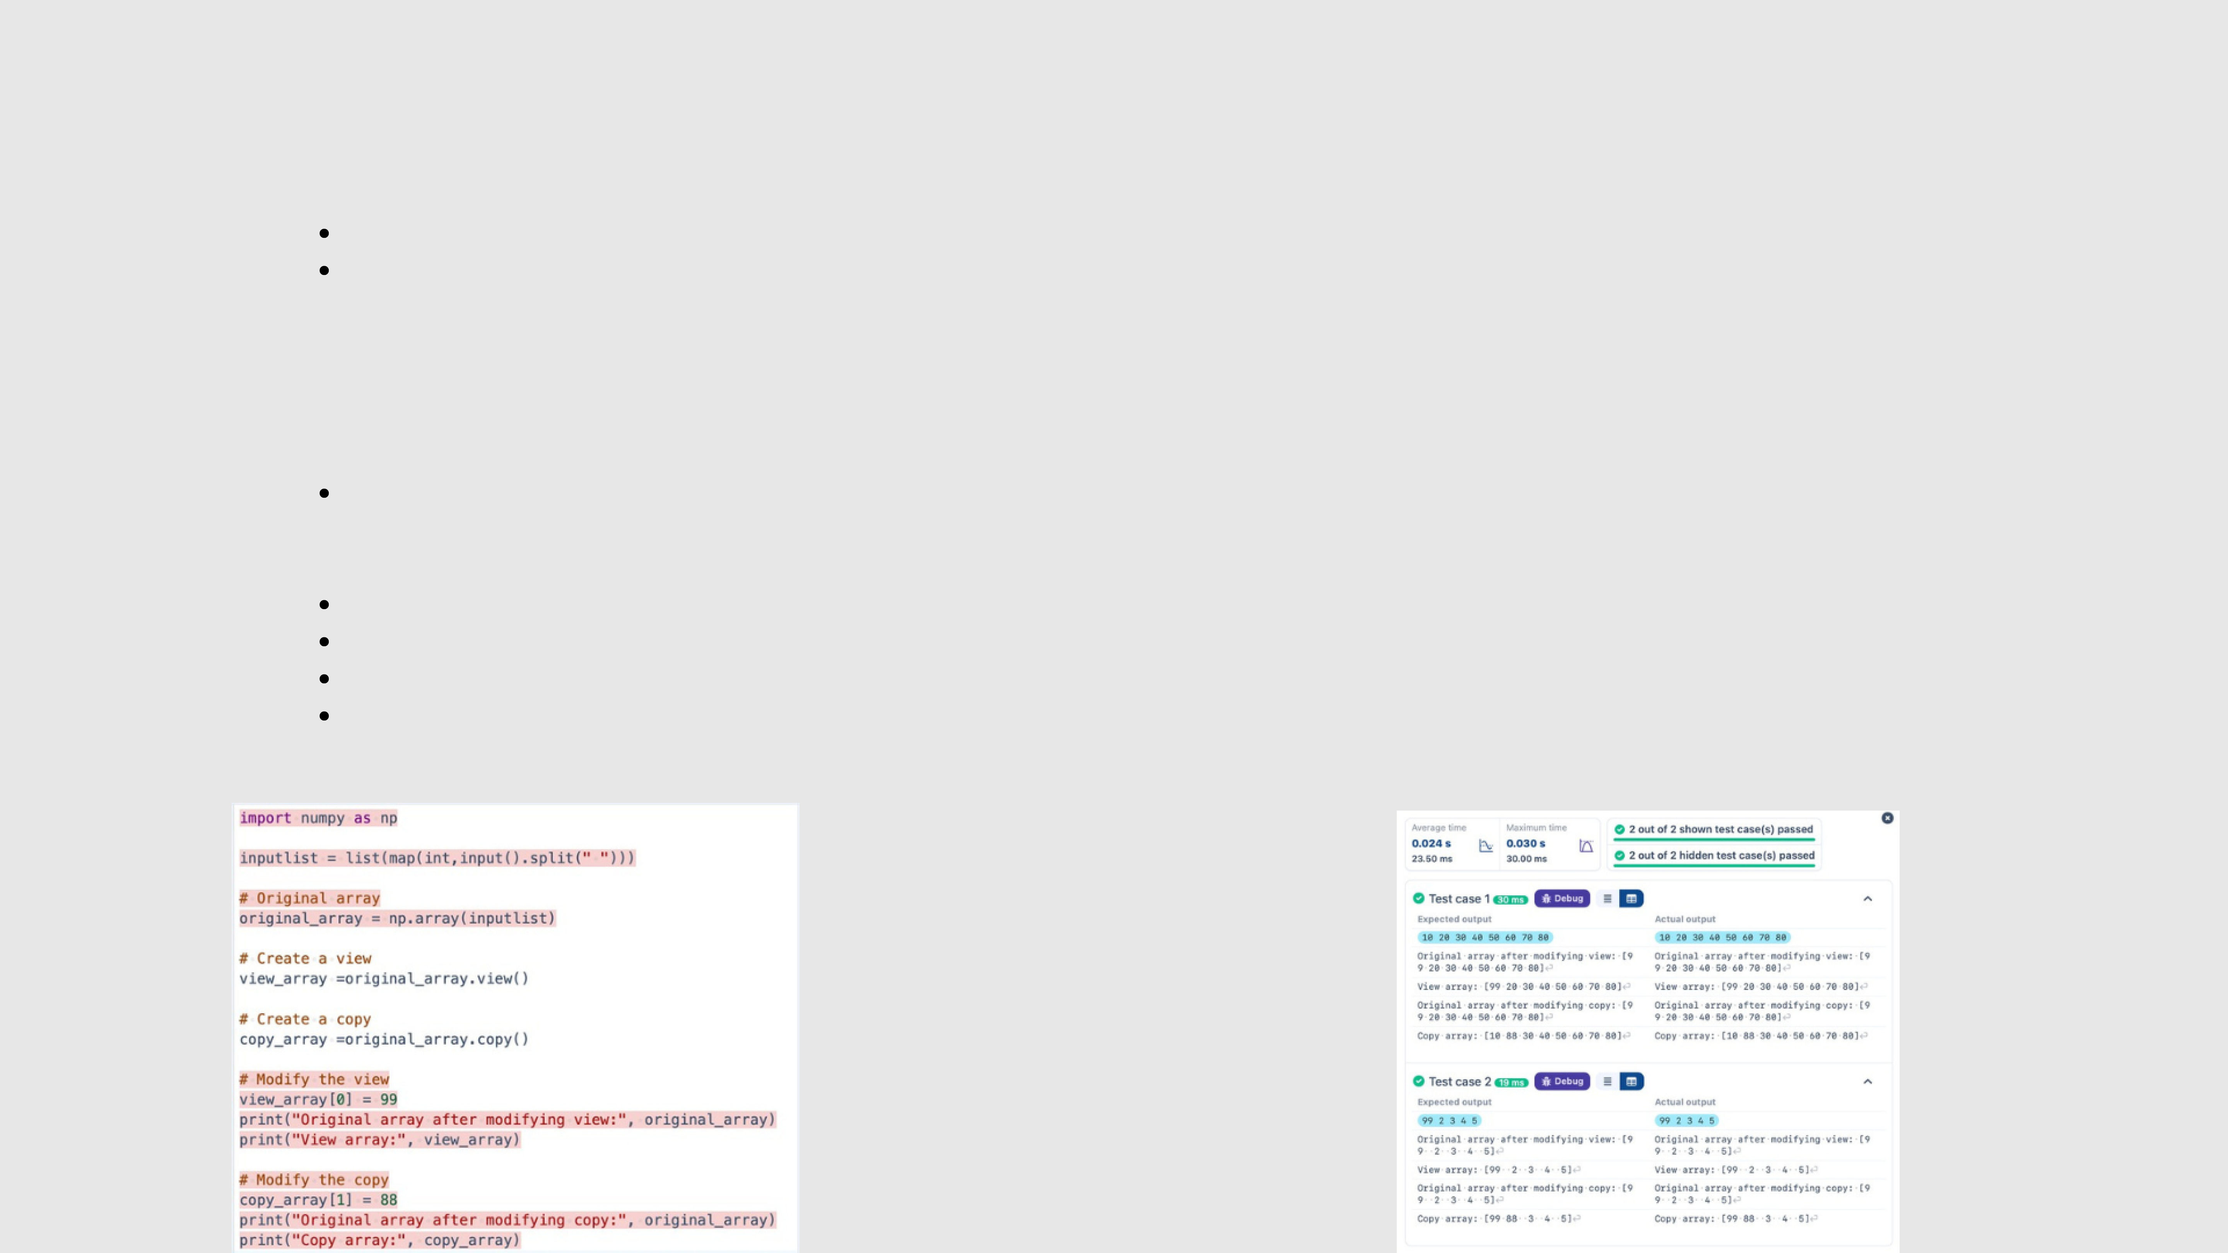
3.2.5 NUMPY:CUSTOM SEQUENCE GENERATION
Thegivencodetakes a list ofintegersasinputandconverts itintoaNumPyarray.Yourtaskistocompletethe code by: Creating a view of the original_array and assigning it to view_array.
Creating a copy of the original_array and assigning it to copy_array.
After completing these steps, observe how modifying the view affects the original_array, while modifying the copy does not.
Input Format:
A single line of space-separated integers.
Output Format:
After modifying the view:Original array after modifying view: <original_array> View array: <view_array>
After modifying the copy: Original array after modifying copy: <original_array>

Copy array: <copy_array>
INPUT

OUTPUT


3.2.6 NUMPY: SEARCHING, SORTING, COUNTING, BROADCASTING
The given code in the editor takes a single array, array1, as space-separated integers as input from the user.
Additionally, it takes the following inputs:
search_value: The value to search for in the array.
count_value: The value to count its occurrences in the array.
broadcast_value: The value to add for broadcasting across the array.
You need to complete the code to perform the following operations:
1. Searching: Find the indices where search_value appears in array1 and print these indices.
2. Counting: Count how many times count_value appears in array1 and print the count.
3. Broadcasting: Add broadcast_value to each element of array1 using broadcasting, and print the resulting array. 4. Sorting: Sort array1 in ascending order and print the sorted array.
Input Format:
1.A single line containing space-separated integers representing array1.
2.An integer search_value represents the value to search for in the array.
3.An integer count_value represents the value to count in the array.
4.An integer broadcast_value represents the value to add to each element of the array.
Output Format:
1.The indices where search_value occurs in array1.
2.The count of occurrences of count_value in array1.
3.The array after adding the broadcast_value to each element.
4.The sorted array.

INPUT OUTPUT

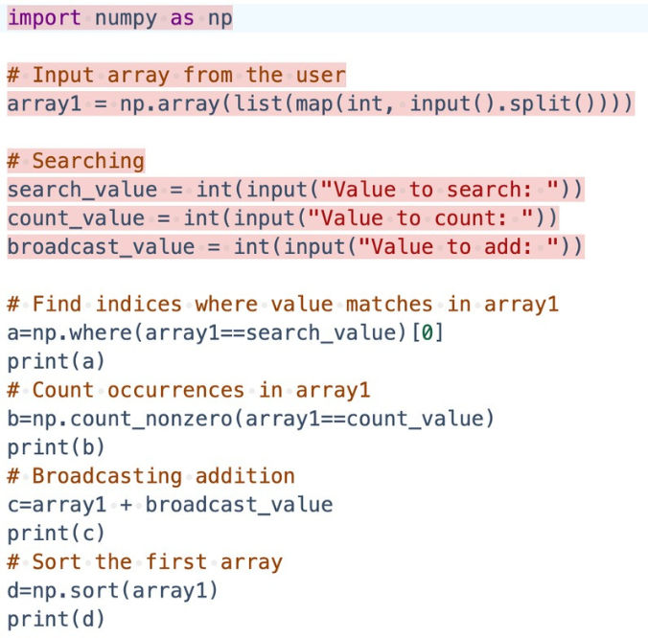

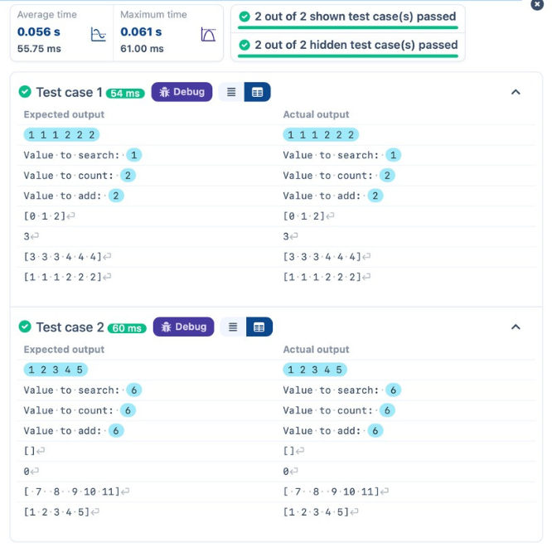


3.2.7 STUDENT DATA ANALYSIS AND OPERATIONS
WriteaPythonprogram that takes the file name of a CSV file containingstudentdetails,includingrollnumbersandtheirmarks in three subjects as input, reads thedata, and performs the following operations:
Print all student details: Display the complete details of all students, including roll numbers and marks for all subjects.
Find total students: Determine the total number of students in the dataset.
Print all student roll numbers: Extract and print the roll numbers of all students.
Print Subject 1 marks: Extract and print the marks of all students in Subject 1.
Find minimum marks in Subject 2: Identify the lowest marks in Subject 2.
Find maximum marks in Subject 3: Identify the highest marks in Subject 3.
Print all subject marks: Display the marks of all students for each subject.
Find total marks of students: Compute the total marks for each student across all subjects.
Find the average marks of each student: Compute the average marks for each student.
Find average marks of each subject: Compute the average marks for all students in each subject.
Find average marks of Subject 1 and Subject 2: Compute the average marks for Subject 1 and Subject 2.
Find average marks of Subject 1 and Subject 3: Compute the average marks for Subject 1 and Subject 3.
Find the roll number of the student with maximum marks in Subject 3: Identify the student with the highest marks in Subject 3 and print their roll number. Find the roll number of the student with minimum marks in Subject 2: Identify the student with the lowest marks in Subject 2 and print their roll number. Find the roll number of students who scored 24 marks in Subject 2: Identify students who obtained exactly 24 marks in Subject 2 and print their roll numbers. Find the count of students who got less than 40 marks in Subject 1: Count the number of students who scored less than 40 marks in Subject 1.
Find the count of students who got more than 90 marks in Subject 2: Count the number of students who scored more than 90 marks in Subject 2. Find the count of students who scored >=90 in each subject: Count the number of students who scored 90 or more marks in each subject.
Find the count of subjects in which each student scored >=90: Determine how many subjects each student scored 90 or more marks in.
Print Subject 1 marks in ascending order: Sort and print the marks of students in Subject 1 in ascending order.
Print students who scored between 50 and 90 in Subject 1: Display students who scored marks between 50 and 90 in Subject 1.
Find index positions of students who scored 79 in Subject 1: Identify the index positions of students who scored exactly 79 marks in Subject 1.
Note: Fill in the missing code to perform the above-mentioned operations.

INPUT | 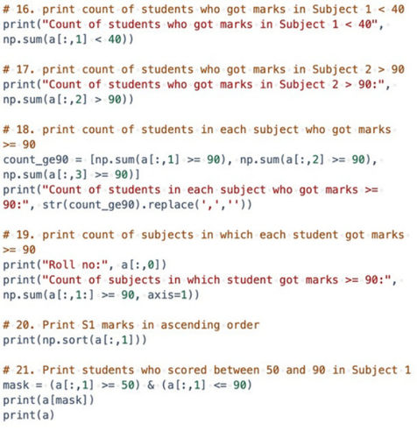 | OUTPUT
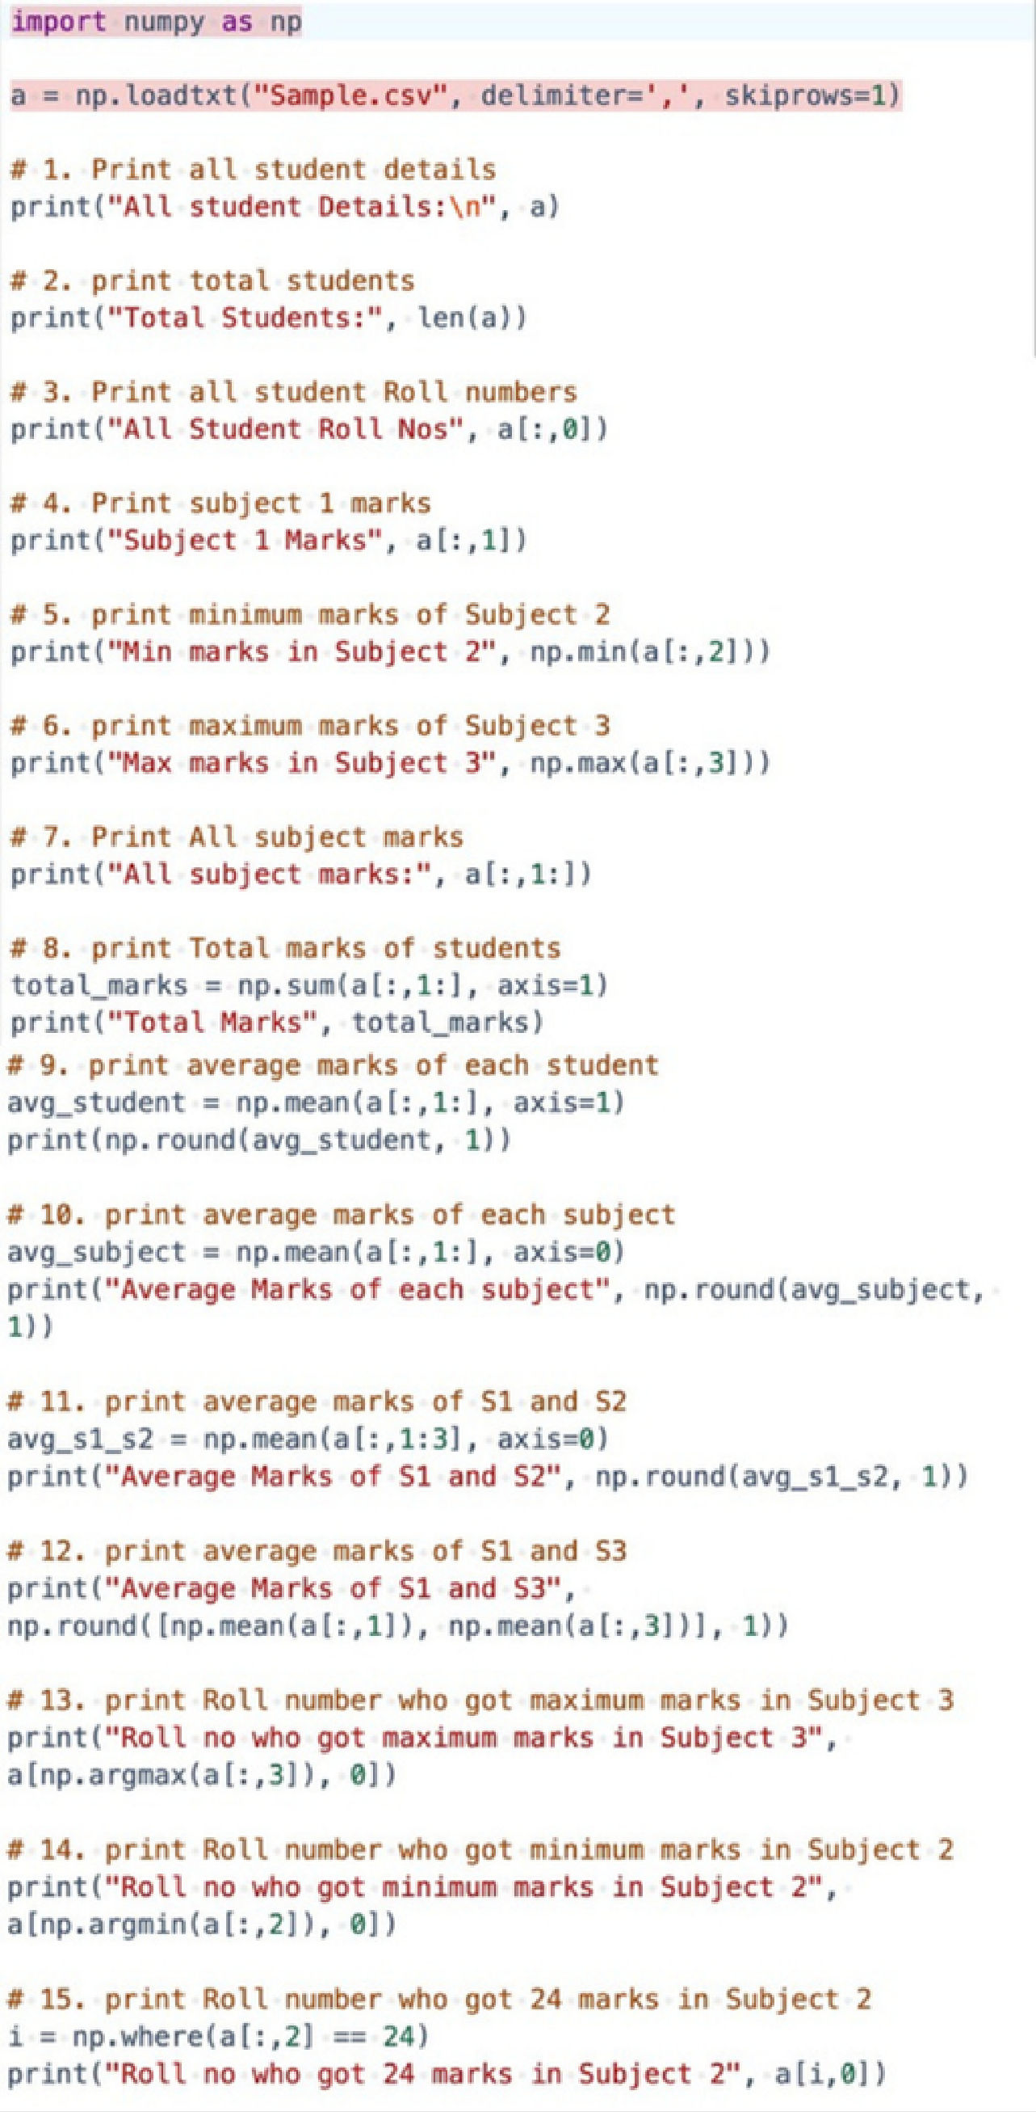 |  | 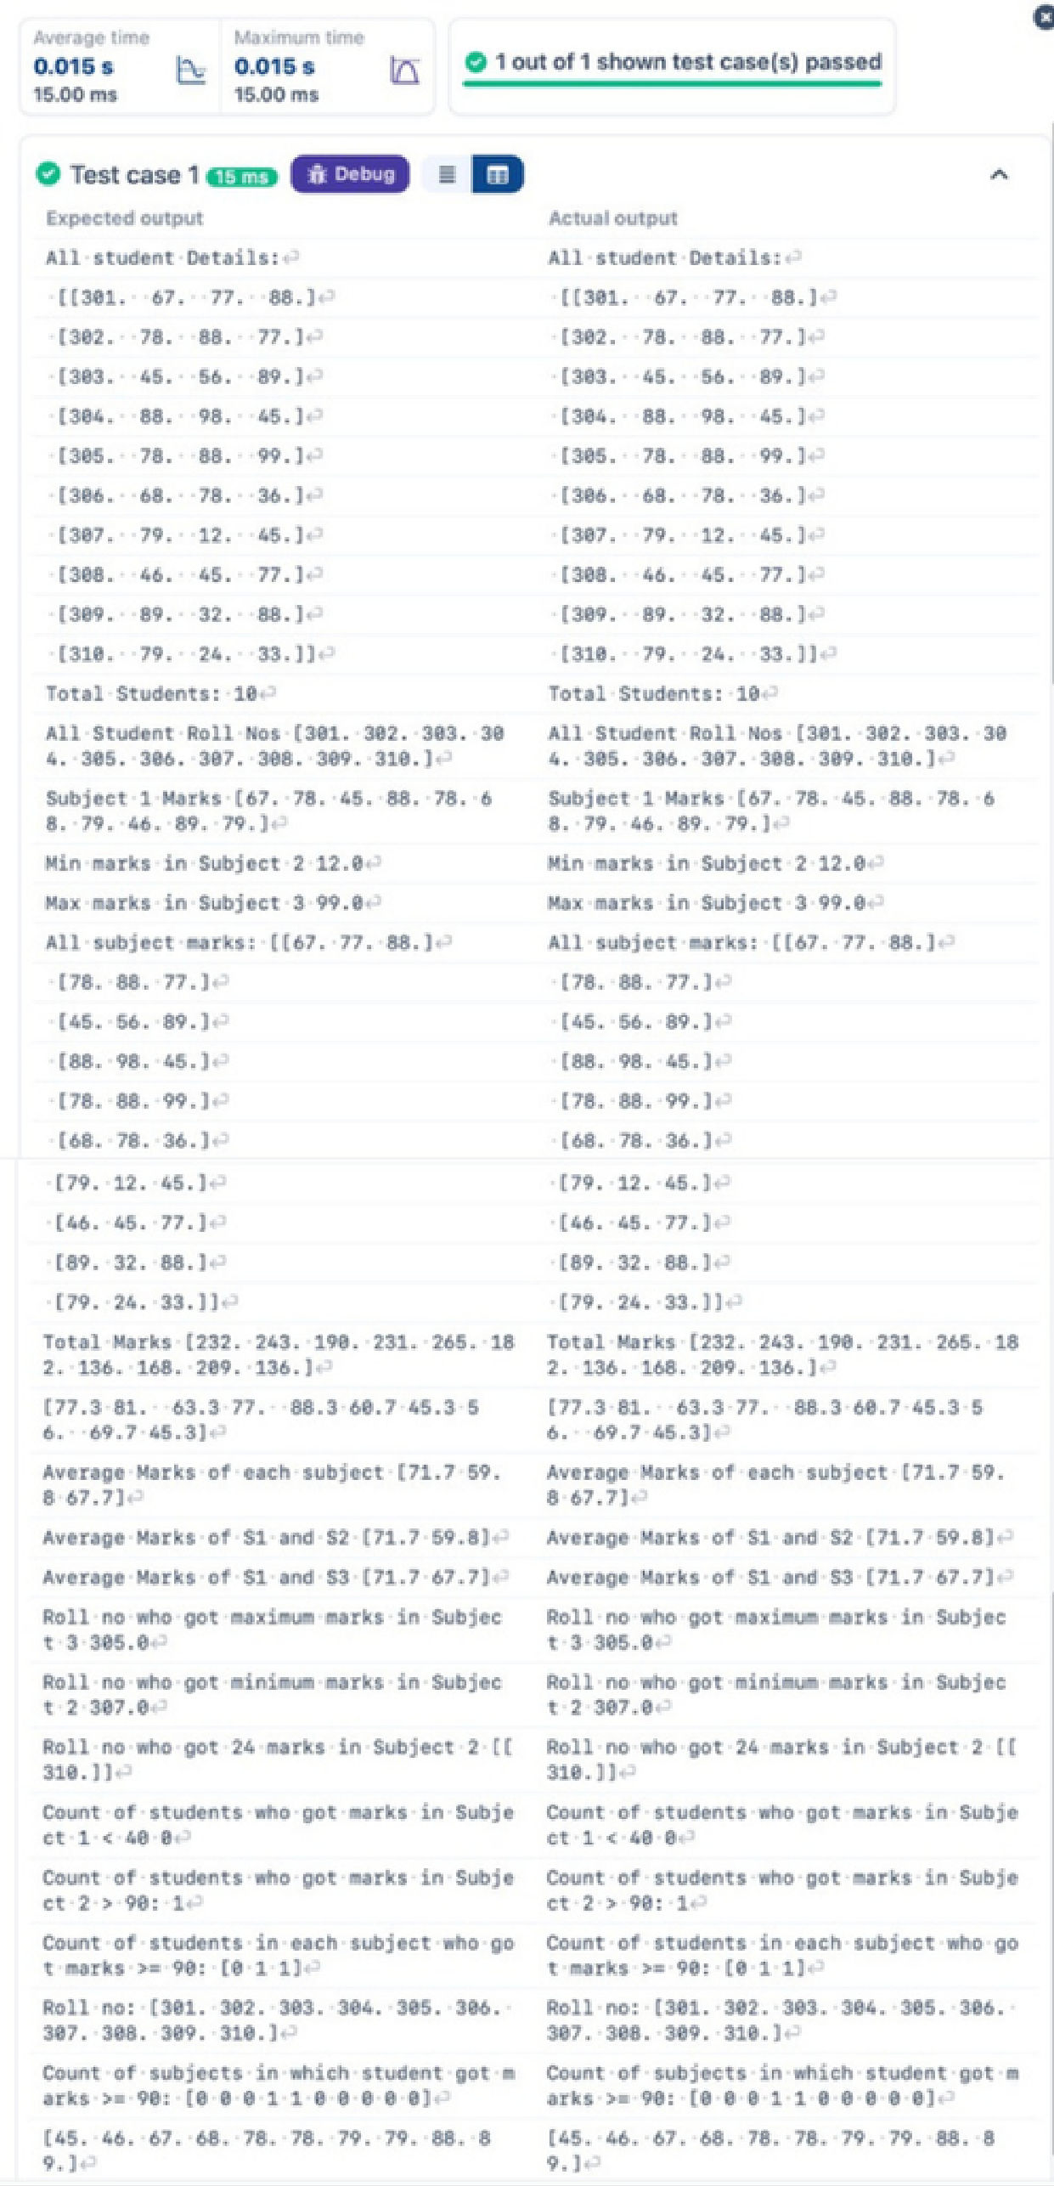 | 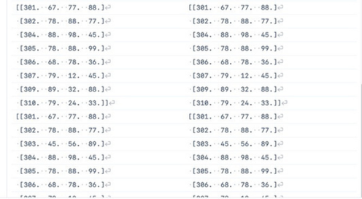
 | 